**CARE GROUP.**

FACULTY NAME:

- Miss Fariha Ahmed.

GROUP MEMBERS:

|  |  |
| --- | --- |
| Student1335831 | Balaj Ahmed Khan. |
| Student1336552 | Hamza Khan. |
| Student1334934 | Muhammad Anas. |

Student 1336473 Syed Muhammad Anas Rizvi.

|  |  |
| --- | --- |
|  |  |



**ACKNOWLEDGMENT**

W

e are thankful to Almighty ALLAH that by His grace we have been successful. We have tried to design the project in such a way that user may not find any difficulty in using this package and further expansion is possible without much effort.

This is our Fifth Semester E-project and we are Alhamdulillah confident enough that this package can be readily used by non-programming personal avoiding human handled chance of error.

We earnestly hope that this project will provide all the necessarily information required for the user to fulfill their inspiration. However suggestions for improvement of the project will be thankful received & acknowledge.

Thank you.

**INTRODUCTION**

The thirst for learning, upgrading technical skills and applying the concepts in real life environment at a fast pace is what the industry demands from IT professionals today. However busy work schedules, far-flung locations, unavailability of convenient time-slots pose as major barriers when it comes to applying the concepts into realism. And hence the need to look out for alternative means of implementation in the form of laddered approach.

The above truly pose as constraints especially for our students too! With their busy schedules, it is indeed difficult for our students to keep up with the genuine and constant need for integrated application which can be seen live especially so in the field of IT education where technology can change on the spur of a moment. *Well, technology does come to our rescue at such times!!*

Keeping the above in mind and in tune with our constant endeavour to use Technology in our training model, we at Aptech have thought of revolutionizing the way our students learn and implement the concepts using tools themselves by providing a *live and synchronous eProject learning environment!*

**So, what is this eProject?**

eProject is a step by step learning environment that closely simulates the classroom and Lab based learning environment into actual implementation. It is a project implementation at your fingertips!! An electronic, live juncture on the machine that allows you to

* Practice step by step i.e. laddered approach.
* Build a larger more robust application.
* Usage of certain utilities in applications designed by user.
* Single program to unified code leading to a complete application.
* Learn implementation of concepts in a phased manner.
* Enhance skills and add value.
* Work on real life projects.
* Give a real-life scenario and help to create applications more complicated and useful.
* Mentoring through email support.

The students at the centre are expected to complete this eProject and send complete documentation with source code to eProjects Team

Looking forward to a positive response from your end!!



**SYSTEM REQUIREMENT**

Hardware

• A minimum computer system that will help you access all the tools in the

courses is a Pentium 166 or better

• 128 Megabytes of RAM or better

• Windows 2000 Server (or higher if possible)

Software

Use software as per your requirement

• Windows OS /Python/R/JAVA/Notepad



**SCREENSHOTS OF CODING**

**ADDCITY**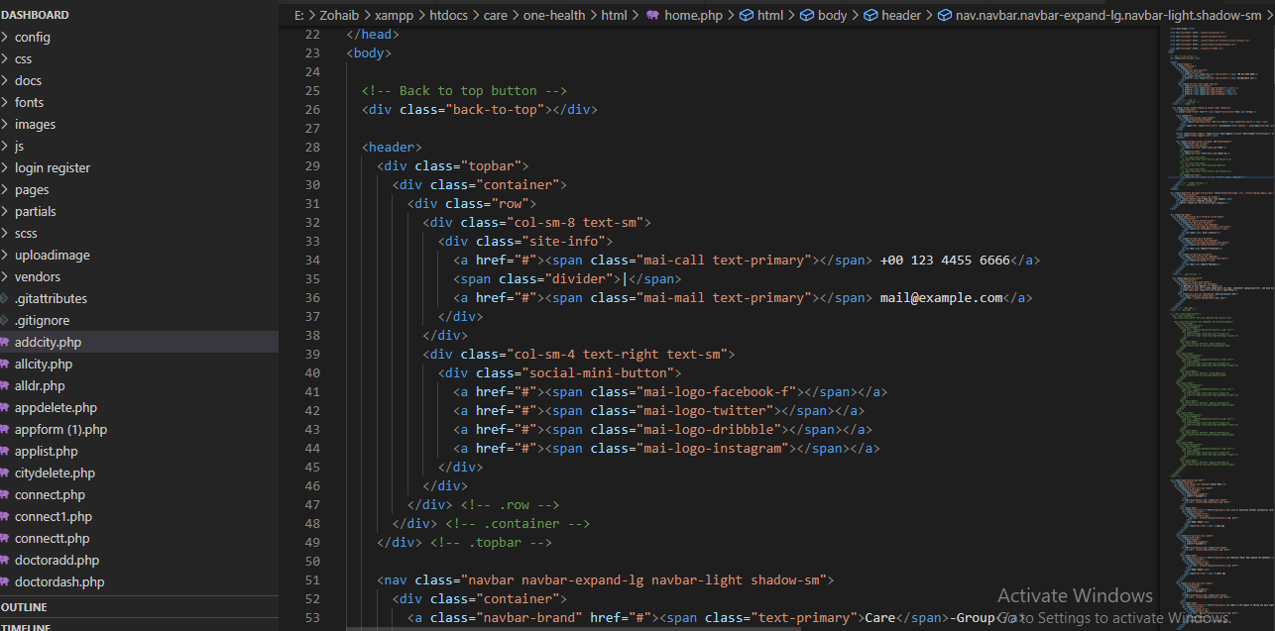

**ALLCITY**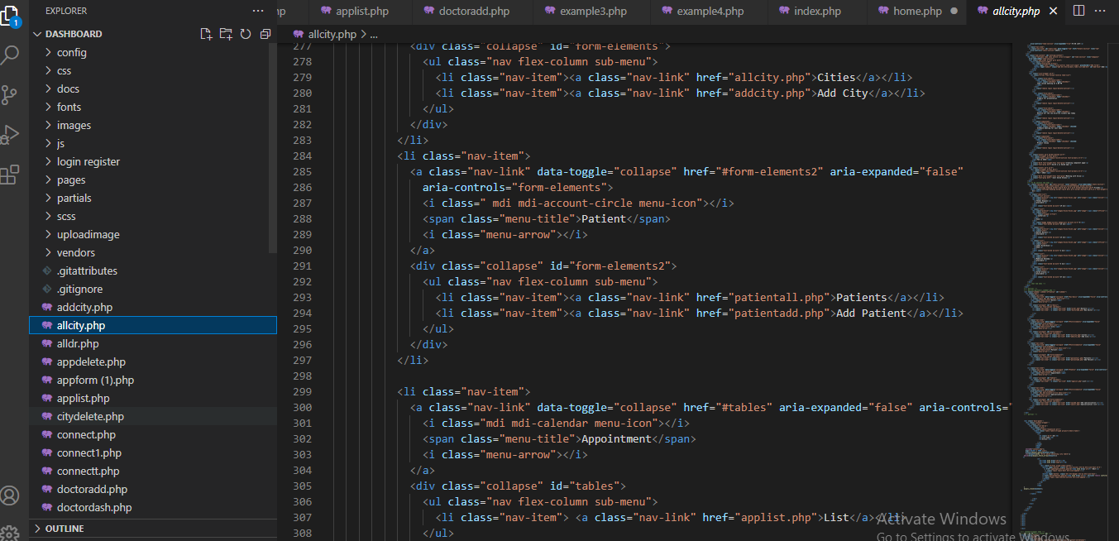

**ALL.DR**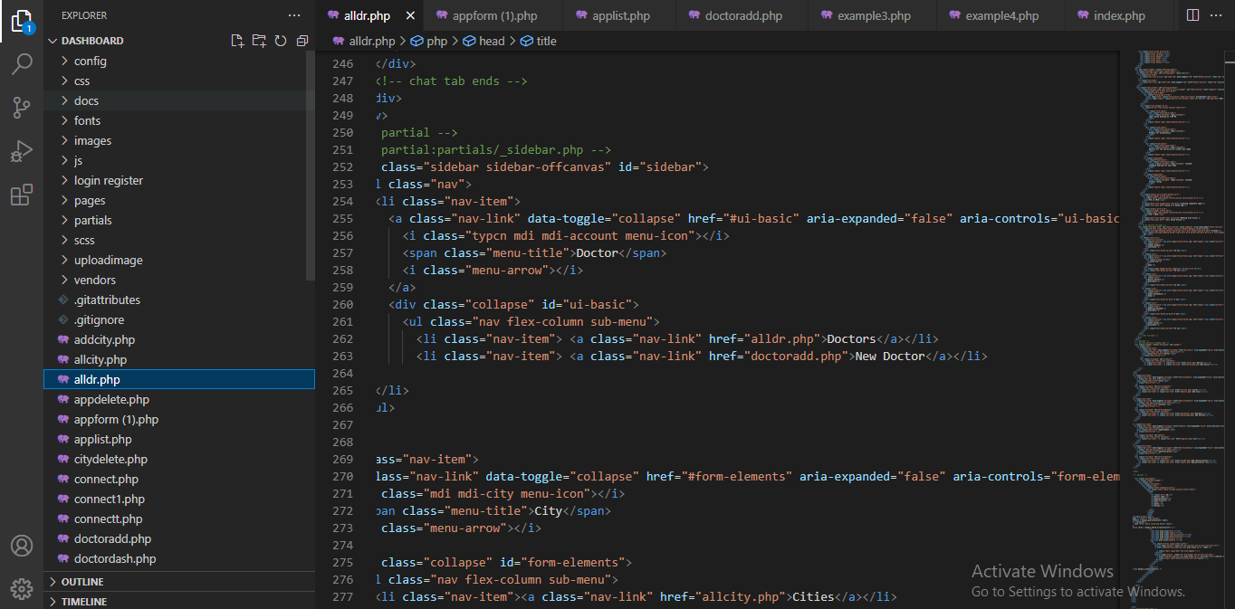

**APP.DELETE**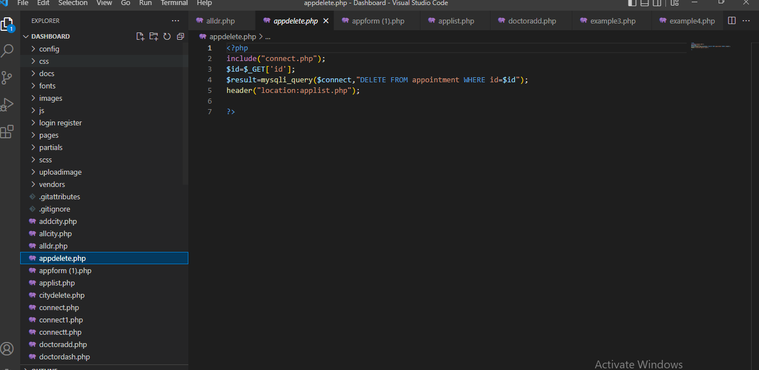

**CONNECT**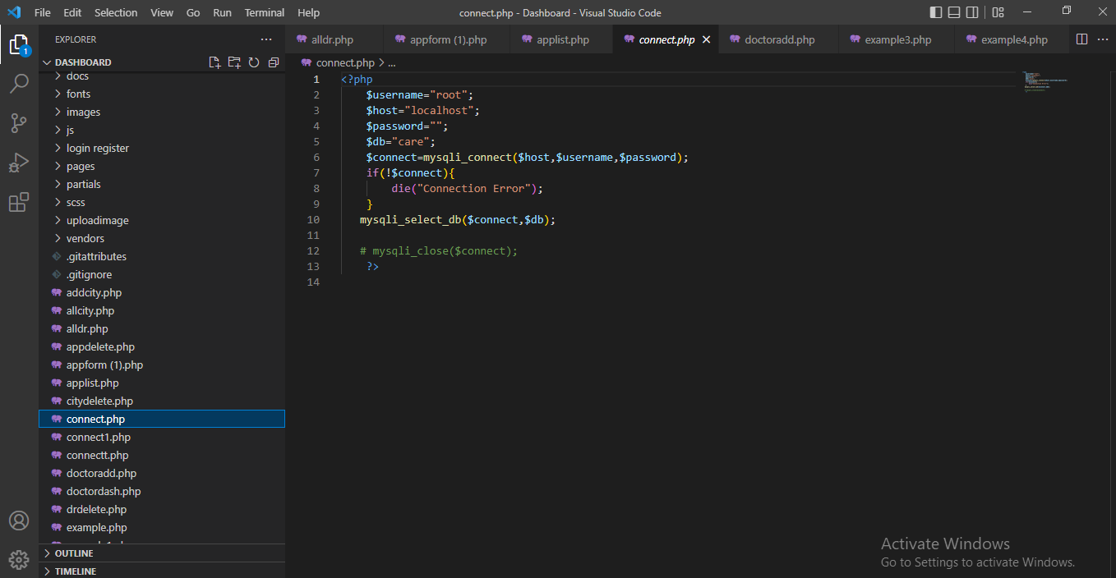

**DOCTORDASH**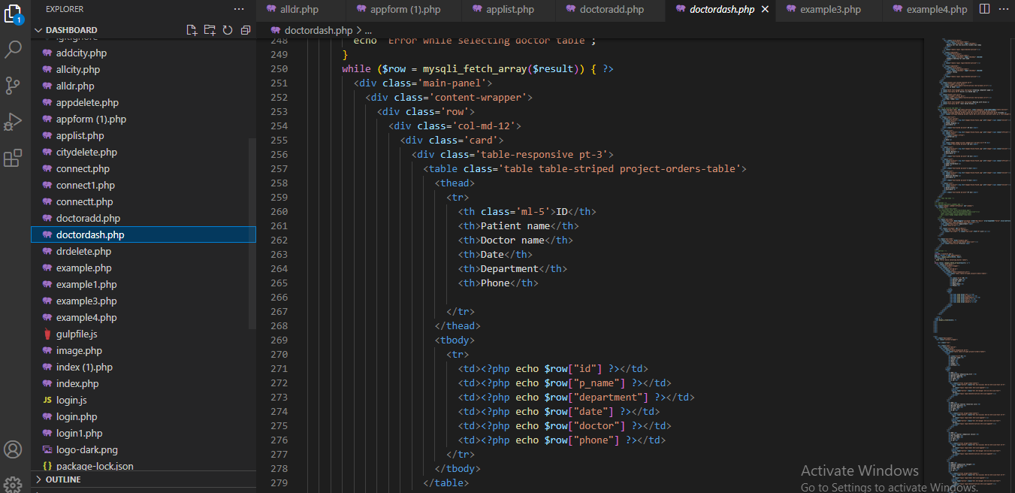

**LOGIN1**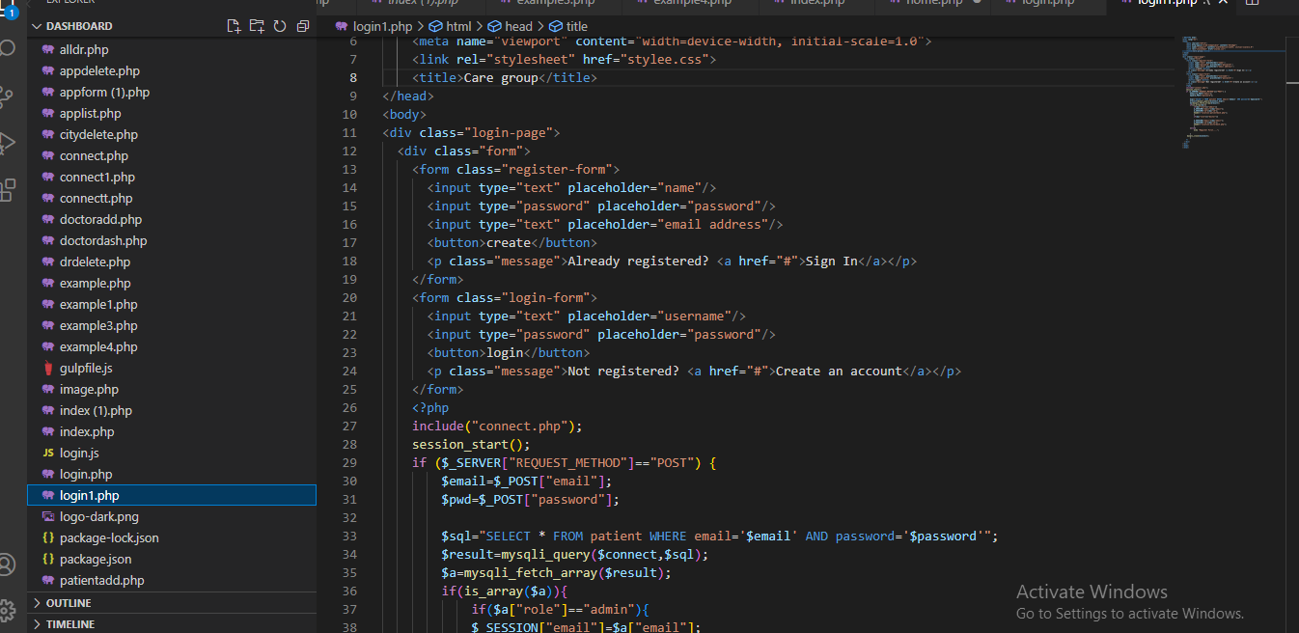

**Update App Form**